Web Browser

A web browser (commonly referred to as a browser) is a software application for accessing information on the World Wide Web. Each individual web page, image, and video is identified by a distinct URL, enabling browsers to retrieve and display them on the user's device. The most popular web browsers are Chrome, Firefox, Safari, Internet Explorer, and Edge.

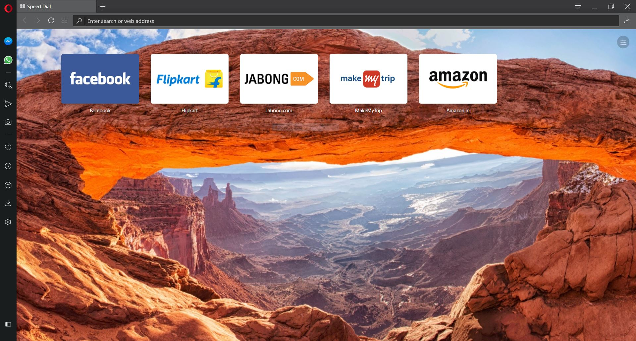

# History

The first web browser, called WorldWideWeb, was invented in 1990 by Sir Tim Berners-Lee. He then recruited Nicola Pellow to write the Line Mode Browser, which displayed web pages on dumb terminals; it was released in 1991. 1993 was a landmark year with the release of Mosaic, credited as "the world's first popular browser". Its innovative graphical interface made the World Wide Web system easy to use and thus more accessible to the average person. This, in turn, sparked the Internet boom of the 1990s when the Web grew at a very rapid rate. Marc Andreessen, the leader of the Mosaic team, soon started his own company, Netscape, which released the Mosaic-influenced Netscape Navigator in 1994. Navigator quickly became the most popular browser.

Microsoft debuted Internet Explorer in 1995, leading to a browser war with Netscape. Microsoft was able to gain a dominant position for two reasons: it bundled Internet Explorer with its popular Windows operating system and did so as freeware with no restrictions on usage. Eventually, the market share of Internet Explorer peaked at over 95% in 2002.

In 1998, desperate to remain competitive, Netscape launched what would become the Mozilla Foundation to create a new browser using the open source software model. This work evolved into Firefox, first released by Mozilla in 2004. Firefox reached a 28% market share in 2011.

Apple released its Safari browser in 2003. It remains the dominant browser on Apple platforms, though it never became a factor elsewhere.

The last major entrant to the browser market was Google. Its Chrome browser, which debuted in 2008, has been a huge success. It steadily took market share from Internet Explorer and became the most popular browser in 2012. It has remained dominant ever since.

In terms of technology, browsers have greatly expanded their HTML, CSS, JavaScript, and multimedia capabilities since the 1990s. One reason has been to enable more sophisticated websites, such as web applications. Another factor is the significant increase of broadband connectivity, which enables people to access data-intensive web content, such as YouTube streaming, that was not possible during the era of dial-up modems.

# Functions

The purpose of a web browser is to fetch information resources and display them on a user's device. This process begins when the user inputs a URL, such as https://en.wikipedia.org/, into the browser. Virtually all URLs on the Web start with either http: or https: which means the browser will retrieve them with the Hypertext Transfer Protocol.

In the case of https: the communication between the browser and the web server is encrypted for the purposes of security and privacy. Another URL prefix is file: which is used to display local files already stored on the user's device.

Once a web page has been retrieved, the browser's rendering engine displays it on the user's device. This includes image and video formats supported by the browser.

Web pages usually contain hyperlinks to other pages and resources. Each link contains a URL, and when it is clicked, the browser navigates to the new resource. Thus the process of bringing content to the user begins again. To implement all of this, modern browsers are a combination of numerous software components. All major browsers allow the user to open multiple pages at the same time, either in different browser windows or in different tabs of the same window. They also support the use of extensions to add to or modify browser operation in a variety of ways.

Common User Interface features of Browsers

1. Back and Forward buttons for back & forth navigation.
2. A Refresh/Reload button to reload the page.
3. A stop button to cancel loading the page (In some browsers, the stop button is merged with the refresh button).
4. A Home button to return to user’s home page.
5. An Address bar/Search bar to input the URL of a webpage or a search query.

# Popular Browsers

## Google Chrome

With Chrome, Google has built an extendable, efficient browser that deserves its place at the top of the browser rankings. As it is cross-platform, incredibly stable, brilliantly presented to take up the minimum of screen space, and just about the nicest browser there is to use. Its wide range of easily-obtained and installed extensions mean you can really make it your own, and there's support for parental controls and a huge range of tweaks and settings to ensure maximum efficiency. Currently, Google is making some moves towards security, and is pushing HTTPS particularly hard. Future versions of the browser will make it very clear when sites aren't using HTTPS encryption, aiming to make it standard throughout the web.

## Mozilla Firefox Quantum

Firefox has always been known for its flexibility and support for extensions, but in recent years it had started to lag behind the competition in terms of speed. Firefox Quantum, first released last year, represented a total overhaul of the browser's code base, with speeds now comparable with Google Chrome. That's not just on top-end computers, either – the new Firefox makes frugal use of RAM, even with masses of tabs open. Quantum also introduced a new system for extensions that prevents rogue developers making malicious changes to the browser's internal code.

Mozilla is a non-profit, which means it doesn't have the same impetus to sell your data as some other browser developers. The organization also makes regular updates to help protect its users' privacy as internet companies come under increasing scrutiny over the way they treat people's data.

## Opera

It's sad that Opera makes up only around 1% of the browser market, because it really is a quality browser. It launches fast, the UI is brilliantly clean, and it does everything its rivals can do with a couple of extras thrown in for good measure.

One of the key reasons Opera to use alongside your main browser is its Opera Turbo feature which compresses your web traffic, routing it through Opera's servers, which makes a huge difference to browsing speed if you're stuck on rural dial-up or your broadband connection is having a moment. It reduces the amount of data transferred too, handy if you're using a mobile connection, and this re-routing also dodges any content restrictions your ISP might place on your browsing, which can be mighty handy.

Opera automatically ducks out of the way if you're using secure sites like banks so your traffic is free and clear of any potential privacy violation. There's also an integrated ad-blocker – which can be switched off if you're morally inclined in that direction – and a battery-saving mode which promises to keep your laptop going for longer.

## Microsoft Edge

The default 'browsing experience' on Windows 10 and unavailable for older operating systems, Edge is an odd one. Integration with Windows 10's core gimmicks seems to be Edge's main strong point. It happily runs as a modern-skinned app on Windows 10's tablet mode, and works with Cortana. It's also highly streamlined for the current web age, doing away with insecure protocols like ActiveX and forcing you into Internet Explorer if you want to use them.

Using Edge is actually a pleasant experience. Its super-quick, hammers through benchmarks, its integrated reading mode makes complex sites more palatable, and by sandboxing it away from the rest of the operating system Microsoft has ensured that Edge won't suffer the security breaches of its older brother.

## Microsoft Internet Explorer

Microsoft Internet Explorer has seen some ups and downs in its long tenure, from dominating the browser charts to languishing behind its main two competitors. This is partly an issue of choice – particularly the browser choice that Microsoft was forced to give customers after a court ruling – and partially because older versions fell behind the rendering and compatibility curve. There are no such issues with Internet Explorer 11. It's clean, powerful, highly compatible, and it demands less of your RAM and CPU than equivalent pages would on Chrome or Firefox. Plus it one-ups both of them on WebKit's Sunspider benchmark. That's not to say this browser is perfect. Google's V8 benchmark sees it struggling, and IE isn't quite as able to handle add-ons and extensions as many of its competitors.

# Bookmarks

In the context of the World Wide Web, a bookmark is a Uniform Resource Identifier (URI) that is stored for later retrieval in any of various storage formats. All modern web browsers include bookmark features. Bookmarks are called favourites or Internet shortcuts in Internet Explorer, and by virtue of that browser's large market share, these terms have been synonymous with bookmark since the first browser war. Bookmarks are normally accessed through a menu in the user's web browser, and folders are commonly used for organization. In addition to bookmarking methods within most browsers, many external applications offer bookmark management.

Bookmarks have been incorporated in browsers since the Mosaic browser in 1993. Bookmark lists were called Hotlists in Mosaic and in previous versions of Opera; this term has faded from common use. Other early web browsers such as ViolaWWW and Cello also had bookmarking features.

Steps to Creating a Bookmark/Adding a Favourite

1. With the desired website open in your browser, select the **Favourites** **button**, and then click **Add to favourites**. You can also press **Ctrl+D** on your keyboard to add a favourite.
2. A dialog box will appear. To **choose a folder** for your favourite, click the drop-down menu in the **Create in:** box, and then select a folder.
3. Click **Add** to save the website as a favourite.

# Private/Incognito Browsing

**Private browsing**, **privacy mode** or **incognito mode** is a privacy feature in some web browsers to disable browsing history and the web cache. This allows a person to browse the Web without storing local data that could be retrieved at a later date. Privacy mode will also disable the storage of data in cookies and Flash cookies. This privacy protection is only on the local computing device as it is still possible to identify frequented websites by associating the IP address at the web server.

The earliest reference to private browsing was in May 2005, and was used to discuss the privacy features in the Safari browser bundled with Mac OS X Tiger. The feature has since been adopted in other browsers, and led to popularisation of the term in 2008 by mainstream news outlets and computing websites when discussing beta versions of Internet Explorer 8. However, privacy modes operate as shields because browsers typically do not remove all data from the cache after the session.

Plug-ins, like Microsoft Silverlight, are able to set cookies that will not be removed after the session. Internet Explorer 8 also contains a feature called InPrivate Subscriptions, an RSS web feed with sites approved for use with InPrivate browsing. The common web browser plugin Adobe Flash Player began supporting privacy mode in Chrome, Firefox, Internet Explorer, and Safari with the release of version 10.1 in June 2010.

Private browsing has multiple uses, including:

* Reducing history, including autofill, browsing, and personal information.
* Performing "pure searches" that are not influenced by prior browsing history or networks or friends' recommendations, which may weight and more highly rank certain results than others.
* Preventing accidental saving of login credentials to accounts.
* Signing into multiple accounts simultaneously, via multiple tabs.
* Testing websites.
* Preventing other users of the computer from finding one's search history.